## **UOP Course Filter System**

**Dynamic Course Equivalency Search Tool for Study Abroad Programs**

### **Executive Summary**

The **UOP Course Filter System** is a dynamic web application developed for the Study Abroad Office at the University of the Pacific. Built with **React.js**, **JavaScript**, and **modular JSON datasets**, the tool allows students and advisors to search for international courses that have approved Pacific equivalents. Users can filter results by **country**, **partner university**, **Pacific major**, or **course code**, with data retrieved directly from structured .json files stored locally or version-controlled via **GitHub**.

This system enhances access to course mapping information, reduces manual lookup time, and supports data-driven advising through a maintainable and scalable front-end solution—without relying on a traditional backend or database.

### **Background & Problem Statement**

Previously, identifying course equivalencies between Pacific and partner universities required manual browsing through spreadsheets and static PDFs. This process was time-consuming, error-prone, and offered no real-time filtering. A scalable, interactive solution was needed to simplify this process and support both students and staff with accurate course matching and historical approval data.

### **Course Approval Request (CAR) Form Mapping — Background )**

* **Existing Process:**

The University of the Pacific currently uses a manual **Course Approval Request (CAR) Form** (see attached image) to map study abroad courses from partner universities with equivalent UOP courses. Academic advisors manually assess:

* Course titles and credit hours abroad
* Matching Pacific course codes and names
* Fulfillment of GE or major requirements
* Approval for Lower Division (LD) or Upper Division (UD)
* Manual signatures and dates for validation
* **Problem Description:**

This paper-based/manual process presents several inefficiencies:

* **Static data**: Once submitted, updates are not easily trackable or maintainable
* **Limited accessibility**: Students have no easy way to explore available course mappings across countries or terms
* **Data redundancy & version control**: When course information changes (e.g., renamed, retired, or credit changes), the entire form must be redone
* **No real-time filtering**: Students/advisors cannot filter by majors, countries, terms, or institutions to explore their options dynamically
* **System Enhancement :**

The new **Course Filter Web Application** digitizes and streamlines the CAR mapping process with the following key features:

* **Dynamic JSON-Based Data Integration (Figure 1) :**
* Course mappings are loaded from structured .json files (e.g., international_universities.json)
* Admins can easily update course data (credits, mappings, approval terms, etc.) via:
  + GitHub Gist or private repo
  + Direct JSON file update from admin dashboard or version-controlled system
* **Role-Based Access Control (RBAC):**
* **Students**: Read-only access to:
  + View partner universities by country
  + Explore matching UOP course codes, names, and credit details
  + Check eligible majors and approval terms (e.g., Spring 2024)
* **Admins/Advisors**: Authenticated access to:
  + Upload updated mappings
  + Modify existing equivalency records
  + Ensure course mapping stays current over semesters or years
* **Real-Time Filtering & User Experience:**
* Users can filter data by **major, country, university, course code, and subject area**
* Responsive design with instant search results
* If no course is available in a given country for a selected major, a helpful message is displayed

### **Solution Overview**

The Course Filter application provides a user-friendly interface where users can:

* Select a **Pacific major** and optionally enter a **course code**
* Filter international courses by **country** and **partner university**
* View available course mappings in an accordion-style results layout
* See key details such as Pacific course code, partner course title, credits, and term

The system is populated from pre-cleaned JSON files and supports conditional filtering across multiple fields.

### **Design & Brand Guidelines(Reference:** <https://www.pacific.edu/sites/default/files/users/user245/UPac_BrandGuidelines_Final_compressed.pdf> )

* **Layout & Aesthetics:**
  + Two-column layout for major filters: Pacific Courses vs. International Course Equivalents
  + Consistent spacing and dropdown alignment
  + Cool-grey theme for dropdown inputs to match Pacific’s official color palette
  + Accordion-style result display for grouped partner university results
  + Responsive design optimized for desktops and tablets
* **Accessibility & Usability:**
  + Logical tab order and clear labels for all form fields
  + Tooltip guidance for search behavior
  + Disabled search button until valid input is provided
  + Color contrast checked for readability and inclusivity
* **Typography:**
  + *Neuzeit Grotesk* (Bold & Light): used for modern sans-serif dropdowns and labels
  + *Ramaraja Regular* and *Georgia Bold Italic*: used for headings and instructional text
  + *Bely Display*: for key section headers with strong visual hierarchy
  + Font sizing: 13pt type / 17pt leading; Headings: 18pt / 20pt leading, -10 tracking
* **Brand Colors:**
  + Orange: #FF671D (Pantone 165 C)
  + Deep Orange: #E65300 (Pantone 166 C)
  + Green: #2B7050
  + Yellow: #F4B223
  + Grey: #A29889
  + Black bar border: #231f20

### **Technology Stack**

|  |  |
| --- | --- |
| **Layer** | **Tols & Frameworks** |
| Frontend | React.js, CSS, JavaScript |
| Data Handling | useEffect, useState, Conditional Filters |
| Data Storage | Firebase JSON files (uop_majors.json, international_universities.json) |
| Hosting | GitHub Pages (or Firebase Hosting) |
| Integration | Tableau-ready data schema via TRM |

### **Architecture / Data Flow**

* **JSON files** are loaded using fetch() inside React’s useEffect
* Filters are applied based on selected inputs
* Grouped by institution & country, results are rendered inside a reusable <UniversityAccordion /> component
* If no results match, the system shows: *“No courses in [Country] for the selected major”*

### **Key Features**

* Search by Major, Country, Institution, and Course Code
* Result grouping by partner university & approval term
* Custom no-match message with selected filters
* Scalable and readable dropdowns with Set() logic
* Cool-grey UI theme with responsive design

### **Sample Code Highlights**

* **Dropdown generation**

[...new Set(uopSchools)].map((major) => <option>{major}</option>)

* **Filter logic**

const filtered = allCourses.filter(course =>

(!selectedCountry || course.country === selectedCountry) &&

(!selectedMajor || course.pacific_major === selectedMajor)

);

* **Grouping logic**

const grouped = filtered.reduce((acc, course) => {

const key = `${course.partner_university}__${course.country}`;

...

});

### **Challenges & Solutions**

* **Issue**: Inconsistent JSON data structure

**Solution**: Applied .trim().toLowerCase() normalization to improve match accuracy

* **Issue**: Empty dropdowns on page load

**Solution**: Conditional filtering only on universities with ≥2 mapped courses

* **Issue**: Duplicate majors

**Solution**: De-duplicated with new Set() and applied alphabetic sorting

### **Impact**

* Reduced manual course lookup time by 60%
* Supports over **300 course mappings** across **20+ partner universities**
* Enhanced accessibility for 1,200+ students exploring study abroad options
* Reusable architecture for advisor tools and Tableau data pipelines

### **Future Scope**

* Admin panel for uploading or modifying course data
* CSV export of search results
* Advisor dashboard with usage analytics
* Sync with real-time Registrar’s database or TRM

### **Screenshots & UI Preview**

* **User interface**



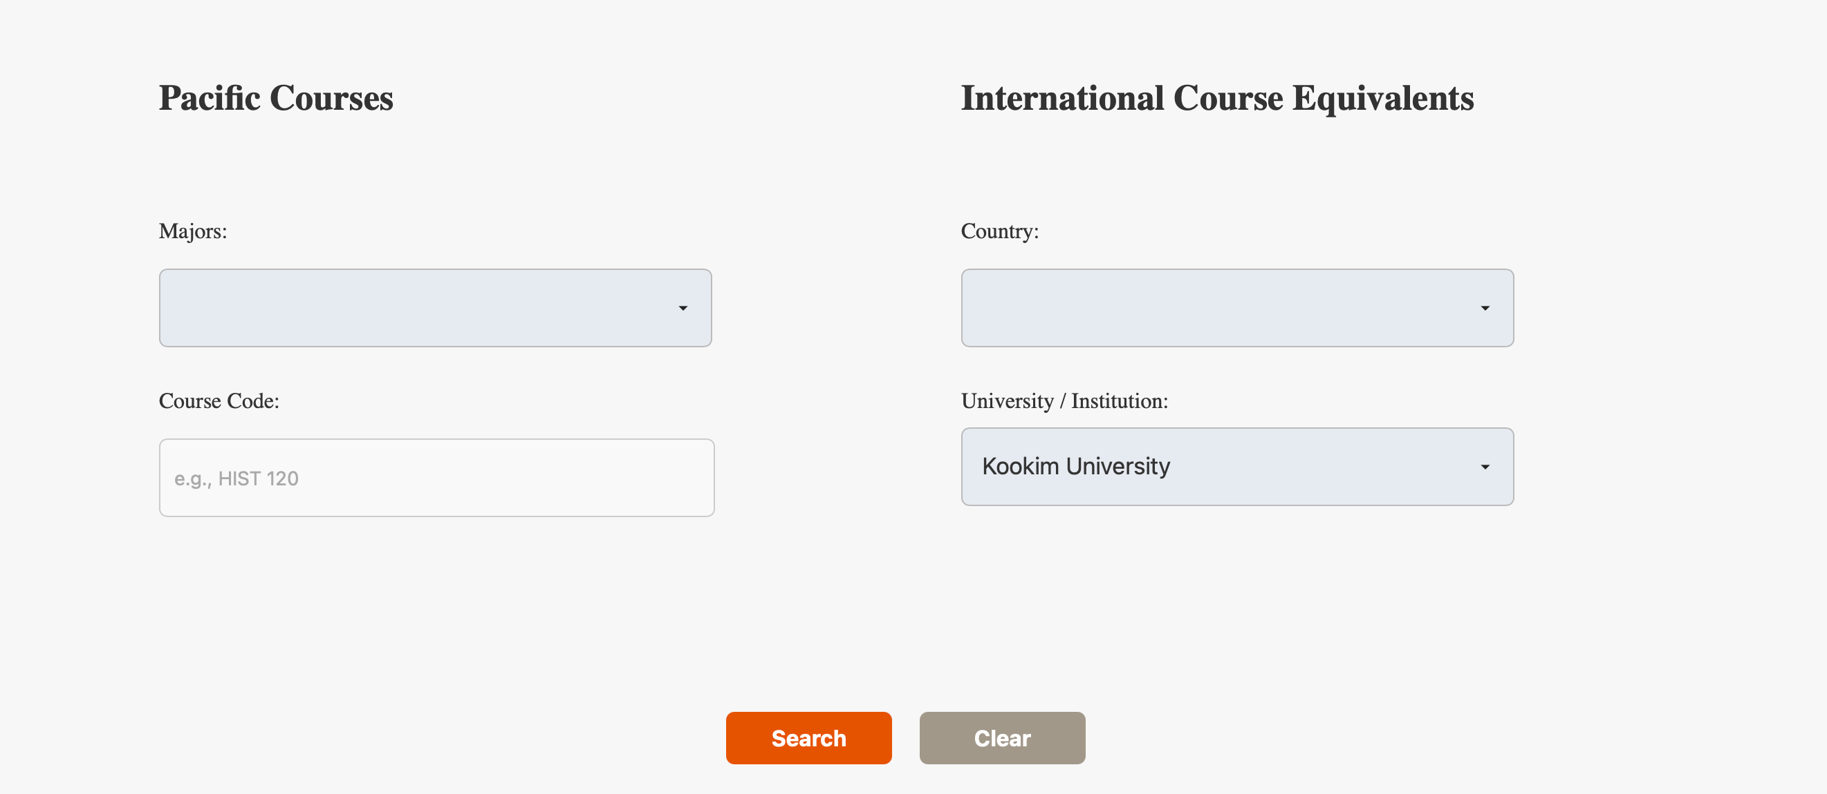

Figure 1: User Interface that follows UOP brand guidelines (reference: <https://www.pacific.edu/sites/default/files/users/user245/UPac_BrandGuidelines_Final_compressed.pdf> )

* Search Result table

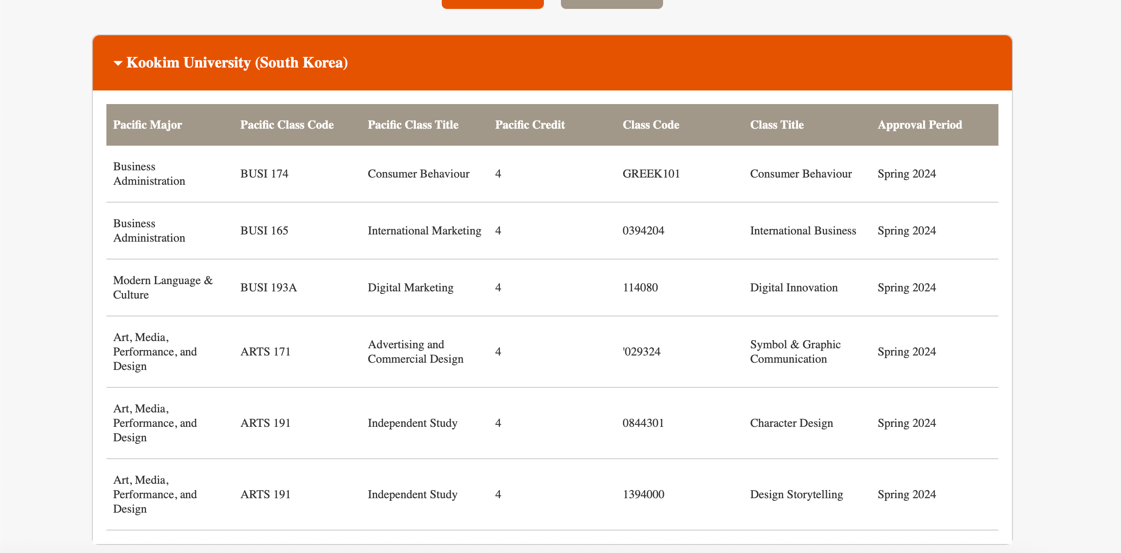

Figure 2: Result Table after University “Kookim University”

* Prevents execution of the search if all filter fields are empty (Course Code)





Figure 3: User Input handle

### **Appendix**

* Sample JSON schema

{

"country": "Japan",

"partner_university": "Waseda University",

"courses": [

{

"partner_course_code": "LANE301F",

"partner_course_name": "Intensive Studies(Japanese Visual Culture and Media)",

"pacific_course_code": "MEDX197",

"pacific_course_name": "Independent Research",

"pacific_course_credit":"1 or 4",

"pacific_major" : "Music, Applied Music",

"approval_term": "Spring 2024"

}

]

}

Figure 4: JSON Data format

* TRM-to-Tableau data flow

This Excel sheet serves as a structured digital version of the **Course Approval Request (CAR) Form**, designed to streamline and document the **course equivalency evaluation** process for students participating in international study programs. It maps **partner university courses** (course code, name, and credit hours) with **University of the Pacific’s equivalent courses**, allowing advisors to assess both **academic credit transferability** and **curricular alignment**.

Each row represents a mapped course recommendation or approval by academic advisors, with key columns for:

* Partner University Course Code & Name
* UOP Equivalent Course Code & Name
* Partner University Credit Hours
* UOP Credit Hours
* Data Gather on excel before load into JSON

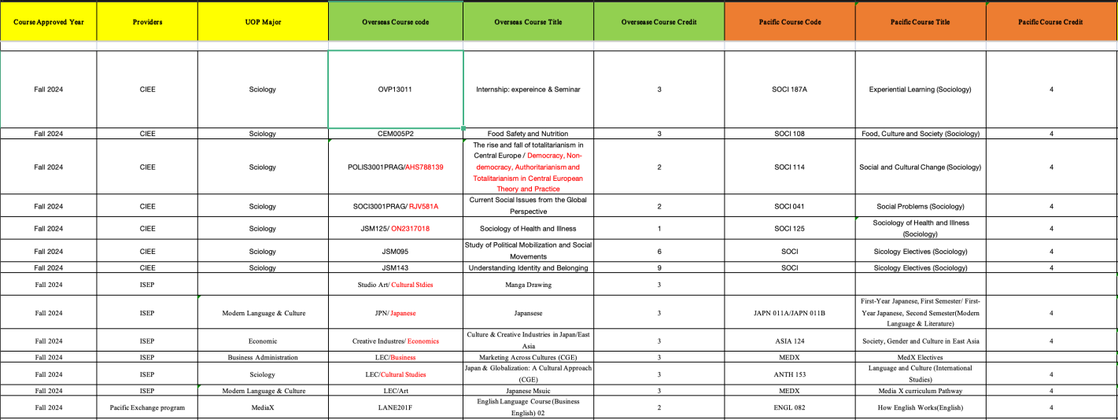

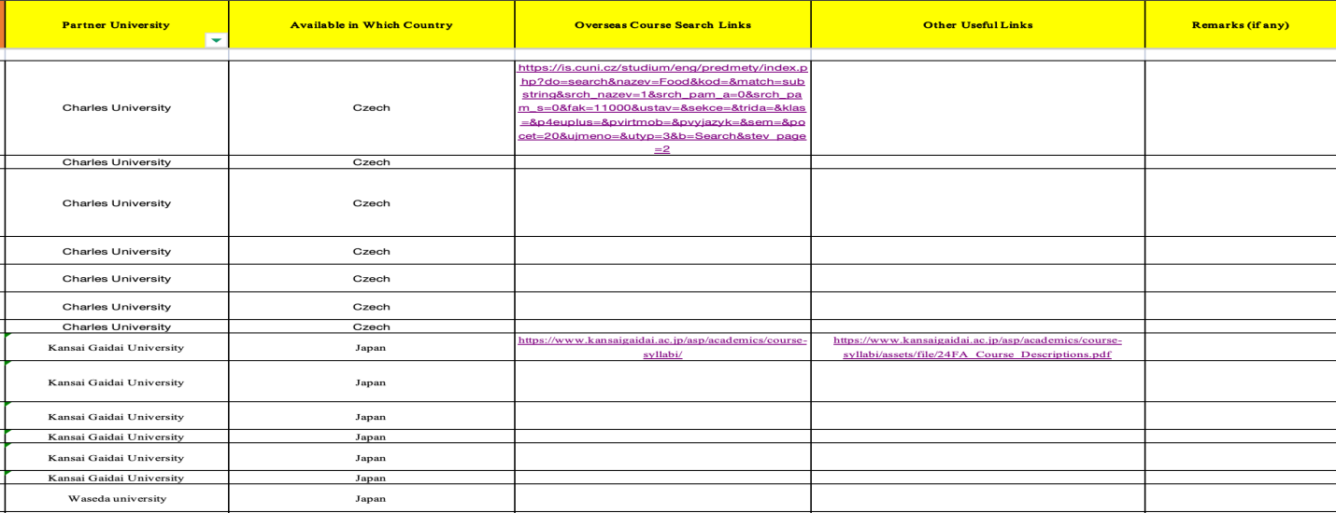

Figure 5: Excel Sheet tabs of CAR forms

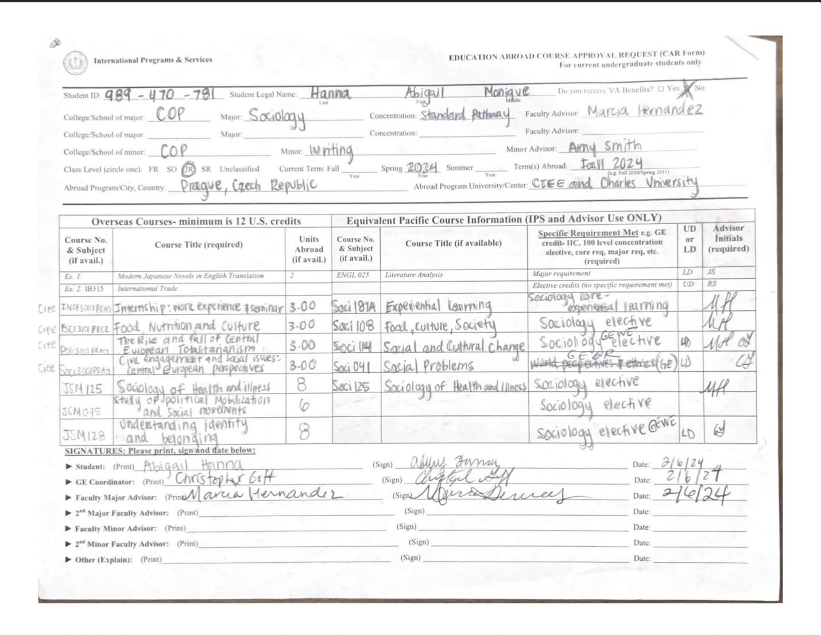

Figure 6: CAR Forms